Bean & Mushroom Tacos
Inspired by


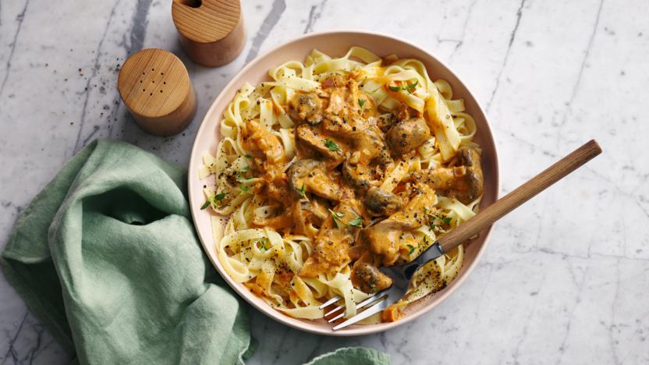
DID YOU KNOW?
“COOL FACT ABOUT BABY GEM LETTUCE!”

Nutrition – Total / Per Serving
Calories: ??kcal / ?kcal
Carbohydrates: ?g / ?g
Protein: ?g / ?g
Fat: ?g / ?g
Fibre: ?g / ?g
Sugar: ?g / ?g
Ingredients
150g of chestnut mushrooms
1 tin of red kidney beans
4 garlic cloves
1 tbsp of tomato puree
2 tsp of Cajun seasoning
75ml of vegetable stock
2 tbsp mayonnaise
½ tbsp Chipotle paste
4 tortilla wraps
100g of Greek style salad cheese (Feta)
1 cob of baby gem lettuce






Good for:

Star Rating:





Method


Step 1 - Preparation
Boil the kettle.
Thinly slice the mushrooms and garlic.
Once the water has boiled prepare the vegetable stock according to the packet instructions.
Drain and rinse the red kidney beans.
Place half of the kidney beans in a bowl and crush with the back of a fork.

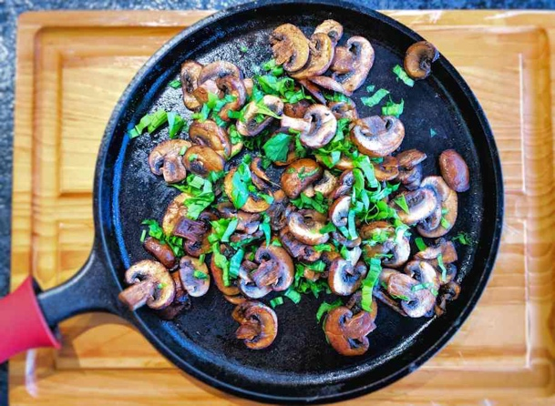
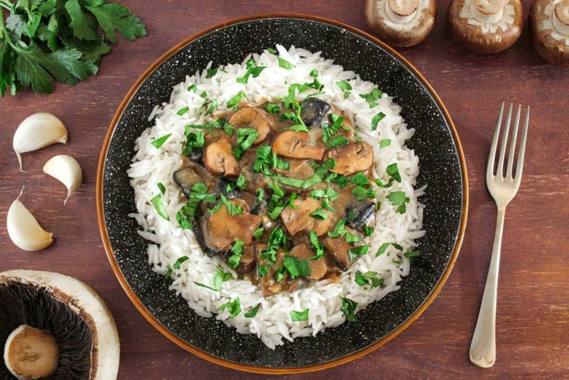
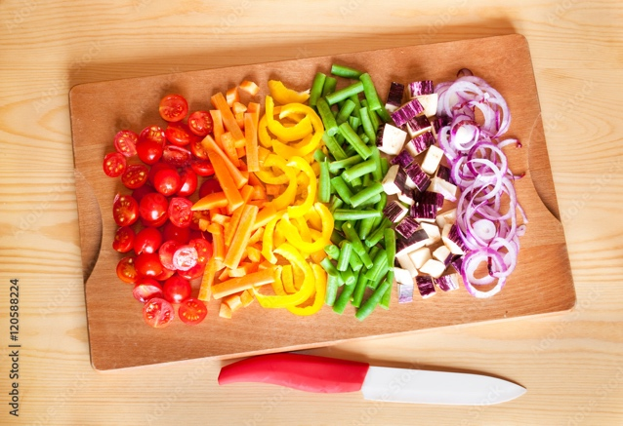
Step 3 – Finishing Touches
In a small bowl, mix together the mayonnaise and Chipotle paste.
Add a small splash of water to loosen up the mixture (you want to be able to drizzle it!).
Place the tortillas onto a baking tray and place in the oven. They only want to be warmed up, so 1-2 minutes should be plenty.
Dice/crumble the Greek style salad cheese.
Cut the baby gem lettuce.
Step 2 – Fry it up!
Heat some oil in a frying pan.
Once hot, add the mushrooms and cook until they have softened and started to colour (~5 min).
Then stir in the garlic, tomato puree, kidney beans (both whole and crushed), and Cajun seasoning.
Mix well before adding in the vegetable stock.
Stir to mix and then reduce the heat to simmer for ~5 mins.
Season with salt & pepper if required.
Step 4 – Building Time!
Place the warmed up tortillas on a place, and build your tacos as you wish!
You could try this order: lettuce first, a healthy spoonful of the bean and mushroom mixture, finishing up with the cheese and a drizzle of the mayonnaise.

Enjoy!

